Cardiac Anesthesia Primer

Table of Contents

Pre-Anesthetic Checklist 1

Anesthesia Start 4

Pre-Bypass 5

Cardiopulmonary Bypass (CPB) 6

Rewarming to Off-Pump 7

Coagulopathy and Transfusion 8

Closing to Transport 9

Miscellaneous 10

SPECIAL CASES 10

Aortic Surgery Requiring Deep Hypothermic Circulatory Arrest 11

Deep Hypothermic Circulatory Arrest: 12

Orthotopic Heart Transplantation 12

Impella Placement 17

Regional Anesthesia in Cardiac Surgery 19

Transfer of Care 19

# Pre-Anesthetic Checklist

* Machine Check
* Suction
* Monitors

|  |  |
| --- | --- |
| * Two pulse-oximeters, one on each hand (one attached to Massimo pulse ox) * Two temperature cables, one on each side of table for the foley (core) and nasopharyngeal (brain) temperatures. * BP cuff | * Edwards Cardiac Output Monitor * Five lead EKG for anesthesia monitor and * Sed Line and cerebral oximeter * Arterial/PA/CVP transducers at head of table * R2 pads for defibrillator |

* Airway
  + General airway set up (advanced airway equipment if indicated)
  + Fill Isoflurane cassette and make sure it is plugged into the machine.
* IVs and Infusion Lines
  + Burette with 500 mL NS: clamp the line from the bag to burette and open the vent to burette chamber
  + Five IV Pumps
  + Blood tubing with warmer, add a stopcock and extension to end of blood warmer tubing
* Drugs:
  + Select drugs are prepared by the OR Satellite Pharmacy
  + Pick up pre-made box at OR Satellite Pharmacy on 3rd floor (**x17955**, open 6:00 AM - 2:30 PM). After hours **orders are filled by the A-level pharmacy, in the order you may request for medications to be delivered to Tube Station 40 in the “Notes to Pharmacy” section of the order navigator.** Tube station 40 is in the south hallway next to OR 1.

|  |  |
| --- | --- |
| * Aminocaproic Acid 20 gram/500 mL NS (run as the carrier at 2 gram/h or 50 mL/h) * Norepinephrine 8 mg/250 mL D5W * Regular Insulin 100 units/100 mL NS * Propofol 10mg/mL - 100mL bottle x 1 * Epinephrine 10 mcg/mL 5mL syringe x 1 | * Phenylephrine 100 mcg/mL - 10mL syringe x 3 * Calcium Chloride 100 mg/mL - 10 mL syringe x 2 * Sodium Bicarbonate 50 mEq/50 mL - syringe/vial x 2 * Albumin 5% - 500 mL bottle x 1 |

* + Induction:

|  |  |
| --- | --- |
| * 20 mL fentanyl (**MAX 10 mcg/kg throughout case**) * 10 mL etomidate or 20 mL propofol per attending preference | * 5 mL lidocaine * 10 mL rocuronium * 2 mL midazolam for patients < 70 years of age |

* Emergency drugs:

|  |  |
| --- | --- |
| * 10 mL of 40 mcg/mL nitroglycerin: 1 cc of 400 mcg/mL diluted in 9 mL NS * 1 gram calcium chloride * 10 mcg/mL epinephrine (premade) * 1 mg emergency epinephrine * 100 mcg/mL phenylephrine (premade) | * 5 mg/mL ephedrine (premade) * 1 unit/mL or 2 unit/mL vasopressin * 10 mg/mL esmolol (available not drawn up) * 1 mL 0.4mg/mL atropine (available not drawn up) |

* Antibiotics:
  + - 1.5 grams cefuroxime
    - 1 gram vancomycin for valve replacements
  + Special Drugs:
    - **Antifibrinolytics** (please notify perfusion which medication and dosing regimen you will be using):
      * *Aminocaproic acid:* 5 gram bolus then start 2 gram/h infusion (50 mL/h)
    - Miscellaneous medications to be given to the **scrub tech, only** for **CABG** cases:
      * 40 mL of 400 mcg/mL nitroglycerin in a 60 mL syringe
      * 5 mL of 1000 units/mL heparin in a 60 mL syringe, after the central line is placed, add 40 mL of the patient’s blood
    - Order **DDAVP** from the pharmacy for patients with any of the following: **renal failure, VAD, Impella, ECMO, OHT (with prior IABP, VAD, Impella), or prolonged pump run**
      * DDAVP dosing/administration: 0.3 mcg/kg (maximum 30 mcg) diluted in 50 mL of normal saline and infused over 20 to 30 minutes
      * Infusion of DDAVP may be associated with hypotension, if so, the infusion rate may need to be reduced
  + Drips:
    - Drip selection is based on the patient’s cardiac condition/function, surgical procedure, and attending preference. Please discuss which drips will be needed for the case with your attending.
    - In most cases, it is reasonable to prepare
      * Aminocaproic acid
      * Norepinephrine 8 mg/250 mL set at 5 mcg/min
      * Nitroglycerin 400 mcg/mL set at 0.25 mcg/kg/min
        + Remember to use the low adsorption pump tubing
      * Insulin 100 units regular insulin in 100mL NS
        + **Any glucose >200 in adults usually warrants treatment**; consider bolusing 4 units and starting an infusion at 1-2 units per hour. Hyperglycemia during bypass can be difficult to treat as hypothermia increases insulin resistance and the cardioplegia solution contains dextrose. Therefore, it is important to trend glucose levels, especially when rewarming as the patient regains sensitivity to insulin.
        + Hyperkalemia can also be a problem during bypass, so the perfusionists may request 5-10 units of insulin to promote intracellular shift of potassium.
    - In most cases, it is reasonable to have an inotrope available, but not spiked: milrinone (20 mg/100 mL set at 0.3-0.5 mcg/kg/min), dobutamine (250 mg/250 mL set at 5 mcg/min), or epinephrine (8 mg/250 mL set at 5 mcg/min).
* Supplemental lines and monitors/Special Considerations:
  + Arterial line kit with sterile gloves
  + CVC kit, most frequently will use 8.5 Fr quad lumen. For redo-sternotomy, patients with EF  30%, complex cases (combined procedures, aortic arch surgery, pulmonary HTN, RV dysfunction, etc) discuss with your attending if a 9 Fr mac and/or PA catheter are needed. Verify the scrub tech has gown and gloves for you for central line placement, if not, pull your gown/gloves and give them to scrub tech.
  + Order TEE: Go to manage orders → New order → TEE (Anesthesia performed).
  + Enter PRN orders for both ABG and VBG.
  + R2 pads should be placed by the RN prior to induction, it is especially important to verify placement for redo-sternotomy, severe aortic or mitral stenosis, left main coronary artery disease, and EF  30%.
  + Please ensure **two** units of PRBC are cross-matched and available. If the case is a redo-sternotomy, blood needs to be in the room and checked prior to incision, and two additional units should be available in the blood bank.
  + To facilitate intra-op charting in LLEAP, select the “Adult Cardiac” macro.
  + Collection of autologous blood prior to heparinization may be considered for patients with a hemoglobin > 13-14 especially with volume overloading valvular lesions such as mitral regurgitation (but avoid in preload dependent lesions such as aortic stenosis and HOCM). **\*\*Please do not collect any blood without discussing with your attending.\*\*** The anesthesia tech/perfusionist may provide a bag with CPD for blood collection. Place a rubber adapter cap (allows the line to be spiked) on the largest central line port, clean the port with chlorhexidine and spike the needle from the CPD bag through cap. Use gravity to allow the blood to drain back, monitor the hemodynamics to ensure the patient tolerates the volume removal. The bag will continue to drain if you do not stop it thus a target volume of ~400 mL is desirable. After the blood is collected, place the blood on the agitator.

**NOW, GO GET THE PATIENT!**

** Plan to be in the room at 7:00 AM **

# Anesthesia Start

* Transport patient to the OR, untie gown, and assist with transfer to the OR bed. If indicated and appropriate, pretreat with midazolam (if < 70 years) and/or fentanyl.
* Attach bilateral SpO2, five-lead anesthesia EKG, blood pressure cuff, sed line, cerebral oximeter, and start pre-oxygenating.
* Place pre-induction arterial line **sterilely** in non-dominate hand (for **aortic surgery** or **radial harvest** cases, **please confirm the preferred location with your attending**). For difficult placement, consider US guidance (see below). The patient should be comfortable and premedicated prior to placement unless contraindicated. Use Stat-Lock bridle device and tegaderm to secure arterial line.
* Prepare for induction and intubation
* Prepare for central line. Most central lines will be placed in the RIJ, turn the head to the left and position the ETT out of the way. The neck may be scanned with US prior to prep to ensure that there is an adequate target. The OR nurse will prep the neck while you scrub.
  + TIP: The echo machine and hockey stick probe will be used for central line placement. Select the IMAGE button on the left selection pane on the echo machine, additional options will appear, including L/R INVERT. This will allow the image to be adjusted so you can hold the ultrasound probe in the manner most comfortable for you.
* Place central line. Draw back blood from each lumen and flush with normal saline. Place clave caps on each lumen.
* After the central line is placed, connect the lines and give antibiotics and antifibrinolytics. **\*\*Please be sure all ports connected to the central line are covered with blue chlorhexidine impregnated caps and that you scrub the hub with chlorhexidine prior to attaching the lines or administering medications.\*\*** For the quad lumen central line- hook blood warmer up to grey port (largest), CVP to blue port, and burette to white port, and drips to brown port.
* Place OG tube, suction stomach, and remove to evacuate any air or contents from the stomach prior to TEE placement
* The fellow or attending will usually place the TEE probe, however you may place the probe with attending supervision. Placement of the TEE probe is very stimulating. Evaluate the patient’s depth of anesthesia and consider supplemental Propofol or fentanyl prior to placement. Place the bite block over the TEE probe and use single use ultrasound gel packet to lubricate the probe. The bite block should be placed between the teeth but should not entrap the lips or tongue.
  + **TIP:** **Place the TEE probe in the mouth,** **grab the lower jaw with your left thumb and lift, gently advance the TEE probe. If the probe does not go easily, try a gentle twisting motion.**
* After TEE probe is inserted, mark TEE probe placement and **ANESTHESIA READY** in LLEAP
* Place wings (metal bars hanging in the back of room) on each side of the bed
* Place the birdcage above the patient’s head.
* Give antibiotics and start aminocaproic acid, both should be given prior to incision.
* Place nasopharyngeal temperature probe and connect temperature cables to the NP (nasal) and bladder (core) probes, ensure the temperatures are labeled correctly on the monitor.

# Pre-Bypass

* Prepare for incision and sternotomy. Incision and sternotomy are very stimulating. Consider re-dosing fentanyl and increasing gas. If the patient is well anesthetized, blood pressure can also be managed with nitroglycerin, as keeping SBP < 140 will help minimize bleeding.
* Prior to sternotomy, the surgeon will ask for ventilation to be held for ~1 minute, this facilitates deflation of the lungs and decreases the risk of lung injury. However, the lungs should remain inflated for redo sternotomy as the inflated lung may offer some protection for the heart.
  + **TIP: Redo-sternotomy requires more time and has a greater risk of complication, including: RV rupture/tear or vessel rupture/tear. It is important to remain vigilant, have blood in the room and checked, and R2 pads placed.**
  + **TIP: For CABG and IMA harvest, decreasing tidal volumes, decreasing PEEP, and increasing RR will aid surgical visualization.**
* The surgeon will notify you when to give heparin. The dose is 400 units/kg and will be given to you by perfusion. Check an ACT **5 minutes** after giving heparin.
* **Minimize IV fluids pre-bypass, < 1L crystalloid if possible.** The pump is primed with crystalloid and there will be significant hemodilution with initiation of bypass.
* The surgeon will begin placing cannulas for cardiopulmonary bypass: 1st aortic, 2nd coronary sinus, 3rd venous cannula into RA appendage for single cannulation or both SVC and IVC for bicaval cannulation, 4th antegrade cardioplegia cannula/root vent
* As the surgeons place the aortic cannula, avoid hypertension. **Goal SBP during aortic cannulation is between 90-110 mmHg.** This helps to limit blood loss and reduces the risk of dissection. Venous cannulation, however, can be associated with hypotension, especially when the heart is lifted for placement of the IVC cannula. PVCs are common for both venous and coronary sinus cannulation due to proximity of SA/AV nodes
* ACT MUST be >480 seconds before going on CPB. If ACT does not increase sufficiently, a second dose of heparin may be required. If the ACT response remains inadequate, then anti-thrombin III deficiency must be considered. Anti-thrombin III deficiency can be managed with FFP or anti-thrombin III concentrate (**590 units** or 1 vial, may repeat if desired ACT not achieved), please discuss these options with your attending.
  + **TIP: During this time, the attending/fellow will be doing the TEE, this is a good time to start getting acquainted with the views.**

# Cardiopulmonary Bypass (CPB)

* Mark “CPB Initiated” in the anesthesia record.
* After discontinuing ventilation and placing the vent in “bag” mode, click procedures and start cardiac bypass, this will silence the vent alarms.
* Disconnect circuit from machine to open lungs to air. Turn flow down and isoflurane off.
* Check with perfusionist to make sure their vaporizer is full, and that isoflurane is on.
* The perfusionist will ask for a pre-bypass urine output total.
* Continue aminocaproic acid and insulin (if needed) infusions. If on vasoactive infusions, discuss with your attending/perfusionist which drips should be continued.
* On the monitor click the alarms button, turn all alarms off and confirm. Change pulse oximeter volume to 0.
* While on bypass, you can:

|  |  |
| --- | --- |
| * Complete charting * Prepare a soft suction catheter * Prepare the transport box * Spike drips for weaning off bypass | * Spike propofol for transport sedation * Prepare drugs for the next case * Review the echocardiogram * Read |

* The cardiotomy suckers/vents used during bypass are color coded. The surgeon and perfusionist will use the colors to communicate management. For example, “up on red,” means increase the suction on the red cardiotomy sucker. Typical color coding is as follows: blue is root vent, white is LV/additional vent, red is a sucker within the chest.

# Rewarming to Off-Pump

* Surgeons will notify perfusionist to start rewarming patient, for **CABG** patients turn on nitroglycerin 0.25-0.5mcg/kg/min. If hypotension is an issue, reduce the rate or discontinue the infusion.
* As the patient’s temperature approaches 34-35C, suction the lungs in preparation for resuming ventilation. Alternatively, you may wait until the surgeon asks you to suction out the lungs.
* Prior to resuming ventilation, the surgeons will request a few gentle breaths to facilitate de-airing. Look at the chest to ensure both lungs re-expand and that, in case of CABG, lung expansion does not stretch the LIMA to LAD graft.
* Page your attending prior to weaning from bypass. Notify your attending when rewarming is started and when the patient’s core temperature is 35C or when the surgeon requests echo imaging.
* As the heart begins to contract, non-sinus or tachyarrhythmias may be present. If the patient is bradycardic, the surgeons may place atrial or ventricular pacing wires. The circulator will provide you with a pacing box and the surgeon will provide you with the pacing cables. Plug the pacing cable into the atrial or ventricular port and verify the desired setting with the surgeon. Typically, the rate is set to 80 bpm with a 10 mA current. **If you are unsure about operating the pacer box or selecting the appropriate settings, please ask your attending for help.** When tachyarrhythmias are present the surgeons may use internal paddles to defibrillate the heart.
* Separation from bypass typically proceeds as follows: 1st perfusionist will give “hotshot,” which is warm blood to washout the cardioplegia, 2nd magnesium and lidocaine will be given by perfusionist (referred to as “goodies” by Dr. Chung), 3rd calcium will be given by perfusionist, 4th the aortic cross clamp will be released (sometimes only indicated by surgeon stating “down on flow, up on blue”), 5th perfusionist will hold blood to fill the ventricles further increasing cardiac function
* When the patient has a good rhythm, air is minimal within left ventricle, ventilation is resumed, drips have been started, and the anesthesia team is ready, the perfusionist will start to hold venous flow, allowing blood to enter the heart and lungs. As the heart and lungs fill with blood, the ETCO2 level will increase.
* Confirm all monitors with appropriate volume are **turned on** and ventilation is adequate
* As the patient is weaned from bypass, continually reassess hemodynamics and cardiac function. Cardiac function should be evaluated by inspecting RV function in the field (RV is the most anterior structure and most visible to the surgeon) and by examining myocardial and valvular function on the echo.
* If the myocardium is “stunned” or contracting poorly, consider an inotrope (milrinone, epinephrine, dopamine, or dobutamine). If heart is contracting well, but the patient is hypotensive assess the volume status. A concave “wrinkled” RV and left ventricular end diastolic dimension < 4 cm are indicative of hypovolemia. If euvolemic, a vasopressor may be required.
* The perfusionist will communicate the protamine dose and anesthesia will draw it up.
* After coming off pump, the surgeon will request a test dose of protamine, give 1 mL of the protamine. Clearly state “test dose in” after the test dose has been given. **\*\*VERY IMPORTANT** DO NOT GIVE PROTAMINE BEFORE THE SURGEON REQUESTS THE TEST DOSE.** Protamine is one of the most dangerous medications in the heart room, as an inappropriately timed dose may cause catastrophic clot formation within the bypass circuitry.
* After administration of the test dose, watch for signs of a protamine reaction:
  + Hypotension
  + Anaphylactoid reactions
  + Pulmonary vasoconstriction
* If there is no sign of reaction, continue to work in protamine.
  + **TIP: Inject into burette and run in slowly or alternatively hand push 1 mL every 2-3 minutes**
* Communicate with the surgeon and perfusionist about the progress of the protamine infusion. When the protamine dose is half-way in, **clearly call out “50% on the protamine.”** The perfusionist should respond, **“suckers are off”** to close the communication loop. When the infusion is complete, call out “all in on the protamine,” notify respiratory therapy, and start a 10-minute timer for the ACT draw, Quantra (aka TEG), and ABG to assess acid/base status, hemoglobin level, and electrolytes
* After the protamine is all in and the cannulas have been removed you can redose your antibiotic
* At this time the perfusionist will ask for a bypass urine total.
* In the meantime, you can give cell saver blood (usually 400-600 mL). Few patients require transfusions, but you made need to order blood products for certain cases/patients and can discuss with surgeon or attending.
* Titrate drips as necessary to maintain hemodynamic goals. Consider albumin for hypovolemia if the hemoglobin level is > 7.

# Coagulopathy and Transfusion

* Hematocrit goals should be discussed with anesthesiologist, surgeon and the perfusionist prior to weaning from CPB. The perfusionist can perform ultrafiltration during CPB to hemoconcentrate.
* Serial viscoelastography with Quantra to evaluate for coagulopathy after CPB
* Platelet dysfunction (quantitative/qualitative) is the most common cause of NON-SURGICAL bleeding post-CPB.
  + - Consider DDAVP
* For refractory coagulopathy may require:
  + **KCentra** (Prothrombin complex concentrate) 25 units/ kg given over 200 units/minute
  + **Factor VIIa** (full dose is 90mcg per kg)
  + **DISCUSS WITH ANESTHESIA AND SURGICAL ATTENDING BEFORE GIVING**

# Closing to Transport

* As the surgeons close the chest, prepare for transport by unhooking unneeded lines (burette) and disconnecting the blood tubing from the warmer. Ensure your drip lines are neat and untangled, and that your push ports are labeled with pink tape.
  + **TIP: Use clear tape or a tourniquet to wrap your drip lines into one bundle**
* Also watch for hypotension with chest closure as this may be a sign of hypovolemia.
* **Obtain a final blood gas** prior to transport to ensure the patient is optimized.
  + **If unexplained hypoxia or hypercapnia, consider CXR prior to transport.**
  + **If significant acid/base disturbances are present, inform the surgical team and your attending, and consider correcting BEFORE transport**
* As the surgeons close the skin incision, start sedation with propofol or dexmedetomidine and wean volatile anesthetic. Remove the TEE probe **(check with your attending to see if the heart needs to be examined before removing)**, remove birdcage and wings, and place an OG tube. Check TOF, DBS, and tetany to determine the reversal dose.
* If the patient requires a PEEP >5, call the anesthesia tech and request a PEEP valve for transport.
* Connect the patient to the transport monitor. Mark “OR to ICU” on the anesthesia record under events.
* Transport with a sedative drip typically propofol 25 mcg/kg/min
* Always bring bolus pressors, anti-hypertensives (nitro/nicardipine), sedative (propofol/etomidate), and reversal
* Always leave fluid line attached to grey port with the push port clearly indicated in case you need to administer emergency medications
* In the ICU, reverse the patient’s neuromuscular blockade.
* Sign out to CTICU team.
  + See ICU Transfer of Care form at end of primer. Please print and fill out then give to receiving ICU physician/NP
* Complete anesthesia documentation including the **transfer of care AND post-op anesthesia note.**
* Bring the pro-pack and transport drug box back to the anesthesia work room. Return the defibrillator to the OR and plug in.

# Miscellaneous

* Post CPB Vasoplegic Syndrome
  + **Methylene blue**
    - Potent nitric oxide synthase inhibitor
    - **2mg/kg** bolus followed by 12hr infusion of 0.5mg/kg/hr gtt

# SPECIAL CASES

## Aortic Surgery Requiring Deep Hypothermic Circulatory Arrest

* Occasionally aortic aneurysm or dissection procedures involving the aortic arch will require deep hypothermic circulatory arrest as the location of the lesion prevents adequate cannulation to supply blood through the great vessels and thus the brain
* This will require significant cooling to ~20C and cessation of systemic circulation on bypass. Blood flow to the brain will be provided via an adjunct limited method by the perfusionist

**Setup:**

* In addition to the cardiac setup, prepare and spike esmolol (2500 mg/250 mL) and nitroglycerin 400 mcg/mL)
  + Nicardipine or cleviprex should be available.
  + Milrinone, epinephrine, and dobutamine, should also be available
* Prepare a 20 mL syringe with 40 mcg/mL Nitroglycerin
* Insulin (1 unit/mL) infusion prepared and spiked
  + Hypothermia increases insulin resistance and most patients will require an infusion to maintain glycemic control during hypothermia
* Order and release 4 PRBC and 4 FFP. Order, but **DO NOT** release, 2 platelets and 1 cryoprecipitate. During CPB discuss anticipated need for platelet and cryoprecipitate with your attending and timing for release.
* Coagulopathy is common with hypothermia and some cases will require two hot lines, please discuss with attending if it is appropriate. One hotline will be used for transfusing blood/cell saver and the other for transfusing other products. This significantly reduces transfusion time. It is **CRITICAL** to anticipate blood product need. All products should be **IN ROOM** and **CHECKED** prior to separation from bypass.
* If a pericardial effusion is present on the preoperative echocardiogram or CT scan, please discuss with your attending as the **presence of pericardial effusion influences the induction plan**
* Place cerebral oximetry (ideally place prior to induction to obtain a baseline reading) and BIS monitors

**Induction:**

* Place pre-induction arterial line in the **RIGHT** radial artery. The **LEFT** subclavian may be involved in the dissection and left radial artery cannulation may not accurately reflect systemic pressure therefore bilateral arterial cannulation may be necessary, please clarify with your attending.
* During CPB, the pressure in the **LEFT** radial artery will most accurately reflect the systemic pressure. Whereas the pressure in the **RIGHT** radial artery reflects the antegrade cerebral perfusion pressure during circulatory arrest.
* Please consider placement of MAC 9 Fr central line with either single lumen introducer catheter or pulmonary artery catheter. Some surgeons may prefer only quad lumen central line, discuss with attending if you are unsure.

**Pre-bypass:**

* Blood pressure and heart rate control is paramount. **GOAL: SBP 90-120 mmHg and HR <90**
* When a **pericardial effusion is present, blood pressure may suddenly increase when the pericardium is opened** surgically and the effusion is drained. **Be prepared to bolus nitroglycerin as needed to maintain SBP 90-120 mmHg.**

### Deep Hypothermic Circulatory Arrest:

* Perfusion will cool to 18-22C during bypass
* Circulatory arrest and cerebral perfusion
* Apply ice to head (3-4 bags of ice applied to head, place towel on head to avoid direct skin contact with ice)
* Pharmacologic neurologic protection may include: propofol, phenobarbital, and/or steroids just prior to circulatory arrest
  + **Discuss with your attending and the surgeon the pharmacologic plan as well as timing of administration.** Depending on perfusion strategy drugs may not reach brain once DHCA has started.
    - Dr. Rabkin prefers either propofol bolus or propofol gtt
    - Dr. Floridia prefers propofol drip prior to the start of DHCA once the temperature cools to 28 degrees
    - Dr. Chung: solumedrol 1 gram IV with induction or prior
* **Cooling increases insulin resistance** and an insulin infusion may be needed to maintain normoglycemia. **Warming restores insulin sensitivity** so insulin requirements may decrease with rewarming. Remain vigilant for hypoglycemia.

**Post-bypass:**

* Expect significant coagulopathy
  + May need to consider administration of factor concentrates such as prothrombin complex concentrate (1500 units infused at 3 units/kg/min)
* Discuss need for epinephrine or milrinone if the duration of bypass is prolonged
* **Discuss blood pressure goals with the surgeon**

## Orthotopic Heart Transplantation

**Preoperative Assessment and Preparation**

* Review available studies including: 12-lead ECG, Holter monitor, echocardiography, stress test, and right/left heart cardiac catheterization
* If a cardiac implantable electronic device (CIED) is present, determine:
  + Type (pacemaker versus implantable cardioverter defibrillator) and manufacturer
  + Settings and pacing dependence
  + Recent events/therapy for arrhythmia
  + Battery life and response to magnet application
* Current level of cardiovascular support: PO drugs, continuous inotrope infusion, and/or mechanical assist devices such as: IABP, LVAD, RVAD, ECLS
* Review laboratory studies
  + Assess renal and hepatic function, which may be affected by low cardiac output or right heart failure.
  + Assess for evidence of coagulopathy or ongoing anticoagulation/anti-platelet therapy

|  |  |
| --- | --- |
| Monitors   * ASA monitors   + Pulse oximeters x2   + Temperature * A-line, 9Fr 2-Lumen (MAC) CVL with CCO PAC (The PA is usually sheathed and inserted into the MAC just past the copper segment. The PAC is typically floated AFTER anastomosis of the new heart.), triple transducer * Cerebral Oximeters x2 * Sedline * R2 pads on and plugged in to defibrillator * TEE * If removing axillary impella or balloon pump place bilateral arterial lines | Medications   * Induction agents: midazolam, fentanyl, ±propofol/etomidate/volatile, NMBDs * Emergency medications: phenylephrine, ephedrine, vasopressin (1 unit/mL), epinephrine (10 mcg/mL and 100 mcg/mL), nitroglycerin (40 mcg/mL), calcium chloride * Aminocaproic acid * Infusions: * Norepinephrine * Epinephrine * Dobutamine * Milrinone * Insulin   **In end stage heart failure, beta receptors are down regulated and response to beta agonists may be decreased** |

|  |  |
| --- | --- |
| Blood Products   * PRBC (4-6 units) and FFP (4 units) in room and checked prior to sternotomy * Prepare platelet (2 units) and cryoprecipitate prior to weaning from bypass, **ONLY release to OR if needed for TRANSFUSION** | Other   * Page RT to set-up inhaled nitric (**iNO**) * iNO should be in-line at the start of the case, but usually started post-bypass * Cefepime and Vancomycin 1gm (redose cefepime after bypass) * Confirm immunosuppression. Typically is methylprednisone, but rarely will be thymoglobulin (see below) |

**Induction and Maintenance**

* Although there are multiple approaches to induction, it is most important to remember end stage heart failure increases:
  + Risk of malignant ventricular arrhythmias, especially with history of VT or previous sternotomy
  + Pulmonary hypertension and RV dysfunction
  + Renal/hepatic dysfunction which impact pharmacokinetics

**Dissection**

* Dissection may be prolonged, prior sternotomy, device implantation, or previous transplant significantly increase operative time (>2 hours vs. <1 hour in an un-operated chest).
* Dissection can be complicated by injury to a prior coronary bypass graft, RV, great vessels, VAD cannula/drive line
* Therefore, blood products must in the room and checked prior to sternotomy

**Cardiopulmonary Bypass**

* Cardiectomy: The recipient heart is removed, usually this includes much of the RA. Only the stumps of SVC and IVC (bicaval technique) and a single left atrial cuff containing all the pulmonary veins are preserved.
* Pulmonary artery catheter is withdrawn then re-floated upon anastomosis of SVC and IVC
* Ideally, the recipient cardiectomy is completed just before arrival of the cardiac allograft to minimize the organ ischemic time (goal ≤6 hours)

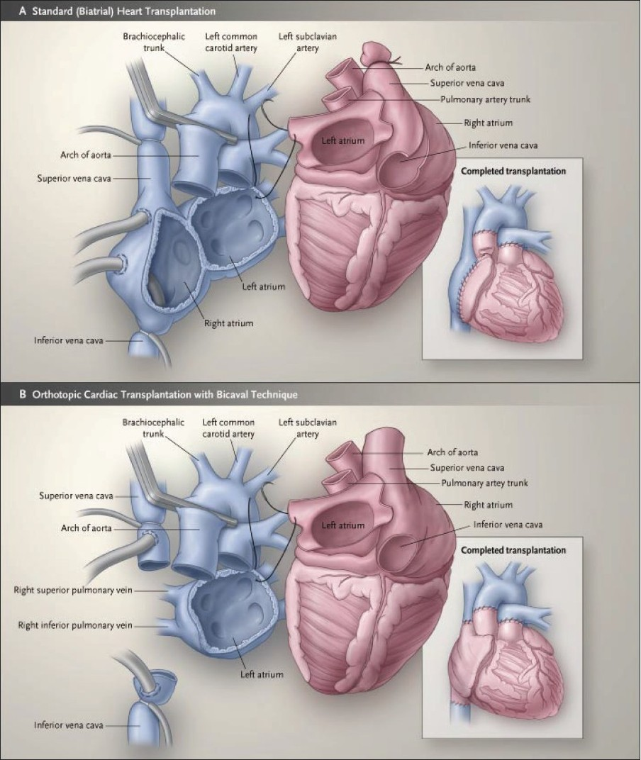

* Leads from preexisting CIED will be cut, and the distal ends will be removed with the recipient heart.
* The left atrial anastomosis is always performed first and is usually followed by anastomoses of the pulmonary artery and the aorta. After de-airing the LV and aorta, the donor heart can be reperfused. The remaining anastomoses can be completed without increasing the ischemic time.
* **Immunosuppressant**: Confirm with surgical team regarding required medication
  + Methylprednisolone (500mg) is **given by perfusionist** after the aortic anastomosis is completed, but prior to the release of aortic cross clamp and reperfusion. Used on the majority of transplant patients vs thymoglobulin
  + Thymoglobulin 125mg/ SoluCortef 20mg/ Heparin 100u/ 500ml over 6 hours
* The donor heart will beat once the clamp is released but may require defibrillation. Epicardial pacing wires are always placed in case pacing is needed.
* The anastomosis of IVC and SVC are performed last (bicaval technique). This is slightly more time consuming than the standard (“biatrial”) technique in which a part of the graft RA is excised to complete the anastomosis. The “bicaval” technique has been shown to result in lower RA pressure, less tricuspid regurgitation, and higher likelihood of sinus rhythm in the graft heart.

**Weaning from bypass**

* Chronotropic support for the denervated heart is routinely provided with epicardial pacing (usually >100BPM) and/or inotropes (epinephrine or dobutamine).
* **The graft heart is denervated** (no direct sympathetic, parasympathetic, or sensory innervation) so it lacks heart rate responses to baroreceptor or volume status changes. **DO NOT GIVE BETA BLOCKERS.**
* Weaning may be prolonged if there is ventricular dysfunction. The RV is most vulnerable to dysfunction, the TEE, CVP, and PAC are repeatedly evaluated to assess RV function. iNO (20 ppm) is routinely initiated during weaning to support the RV (remember to increase the fresh gas flow to avoid rebreathing and NO2 buildup).
  + Surgeons often use CVP as a surrogate for RV preload and a rising CVP may suggest worsening RV function. Please avoid using the port transducing CVP for giving and flushing medications.
* The graft heart, due to ischemia and reperfusion, may have significant diastolic dysfunction and can be very preload sensitive. CVP, PAD, TEE, and visual inspection of the RV are used to assess volume status. Communication between the anesthesiologist and the surgeon is vital for establishing the optimal fluid balance.
* Significant vasoplegia can occur and may be compounded by inodilators such as dobutamine or milrinone. High-dose norepinephrine and/or vasopressin infusion may be needed to maintain MAP.
* Serial ABG to evaluate for metabolic acidosis, which can be due to hypoperfusion on CPB, graft dysfunction, low output, or high dose vasoconstrictors.

## Impella Placement

* Temporary mechanical circulatory is used as bridge therapy for advanced stage heart failure as well as acute cardiogenic shock. Impella is a percutaneous ventricular assist device positioned in the left ventricle through the aortic valve. Blood is drawn from the left ventricle into the device and ejected into the aorta, thereby offloading the left ventricle and augmenting cardiac output.
* Smaller Impella devices that support up to 3.5 L/min flow can be placed with in the cath lab through the femoral artery. However, larger devices with the capacity to support 5.5 L/min of flow must be placed though the right axillary artery via percutaneous access or cutdown. Placement does not require CPB.

**Preoperative Assessment and Preparation**

* Review available studies including: 12-lead ECG, Holter monitor, echocardiography, stress test, and right/left heart cardiac catheterization
* If a cardiac implantable electronic device (CIED) is present, determine:
* Type (pacemaker versus implantable cardioverter defibrillator (ICD)) and **manufacturer**
* Settings and pacing **dependence**
* Recent events/therapy for arrhythmia
* Battery life and response to magnet application
* Majority of these patients will have an ICD due to their cardiomyopathy thus the device rep should be **contacted** the day before or that morning to reprogram the device (LLU patients SHOULD be managed by our EP team, but they are not always available). The surgical site will be in close proximity to the generator and electrical interference from the cautery is possible.
* Current level of cardiovascular support: PO drugs, continuous inotrope infusions
* Review laboratory studies
* Assess renal and hepatic function, which may be affected by low cardiac output or right heart failure.
* Assess for evidence of coagulopathy or ongoing anticoagulation/anti-platelet therapy
* Medications and infusions
  + Induction medications as per cardiac primer
  + Cefuroxime, Vancomycin (verify with surgeon prior to administration)
  + For patients on dopamine, dobutamine, or milrinone and those should be continued unless otherwise instructed by attending
  + In addition to current vasoactive medications, prime norepinephrine, epinephrine, and insulin

**Induction:**

* Place pre-induction arterial line in the **left** radial artery. A **right** radial arterial line should be placed after induction to monitor pressure distal to the right axillary artery.
* Discuss with surgeon and your attending if placement of MAC 9 Fr central line with pulmonary artery catheter is indicated. The hemodynamic information from the PA catheter may help guide management in the ICU.
  + Many of these patients have single lumen PAC from the cath lab already in place

You still may have to place another PAC and central line as cath lab PAC are

not compatiable with our monitors and have insufficient lumens

* If patient has significant pulmonary HTN or right heart dysfunction discuss utilizing iNO

**Emergence/ Extubation**

* Plan to extubate in the OR as long as patient is hemodynamically stable
* Transport with monitors to ICU (same as every other cardiac case)

## Regional Anesthesia in Cardiac Surgery

* Regional anesthesia may be appropriate for some cardiac surgical patients. When indicated, a sternal plane block will be performed in the operating room and supervised by the attending performing the case.
* The most common block will be the pecto-intercostal fascial plane block (PIFB).

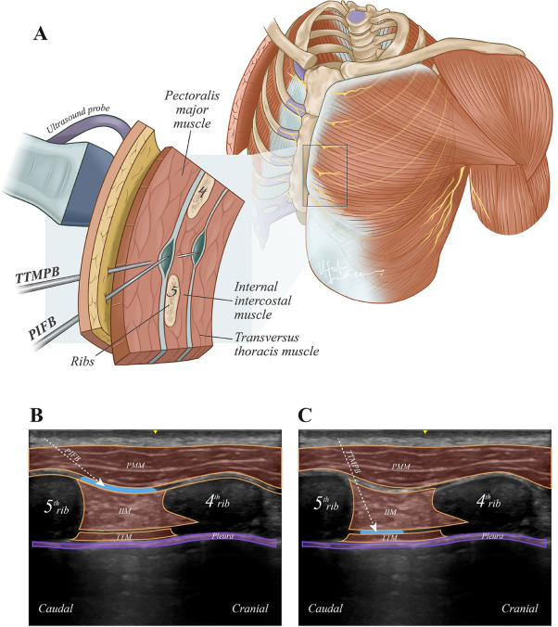

* Please discuss if regional anesthesia is warranted with your attending during your pre-op.
* Consent the patient for a sternal plane block the AM of surgery
* You will need a 21g x 4inch echostim/stimuplex needle and ultrasound machine to perform the block
* This will be performed in the operating room, after the chest dressings have been placed, using sterile technique to minimize any possibility of surgical site infection
* Discuss with your attending the quantity and concentration of ropivacaine for the block

## **Transfer of Care**

